### Axe DevTools Staging Scan Result: form 22-10282

Conclusion: no a11y issues detected

1. [Intro page](https://staging.va.gov/education/apply-for-education-benefits/10282/introduction)

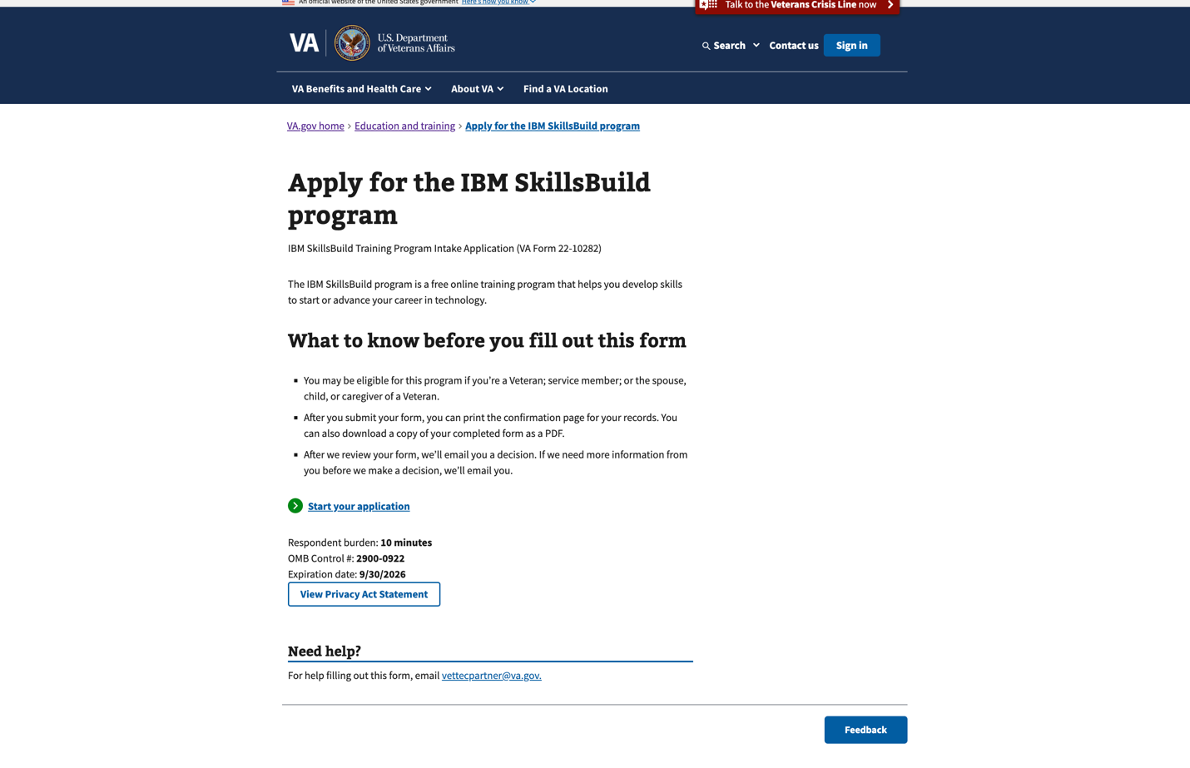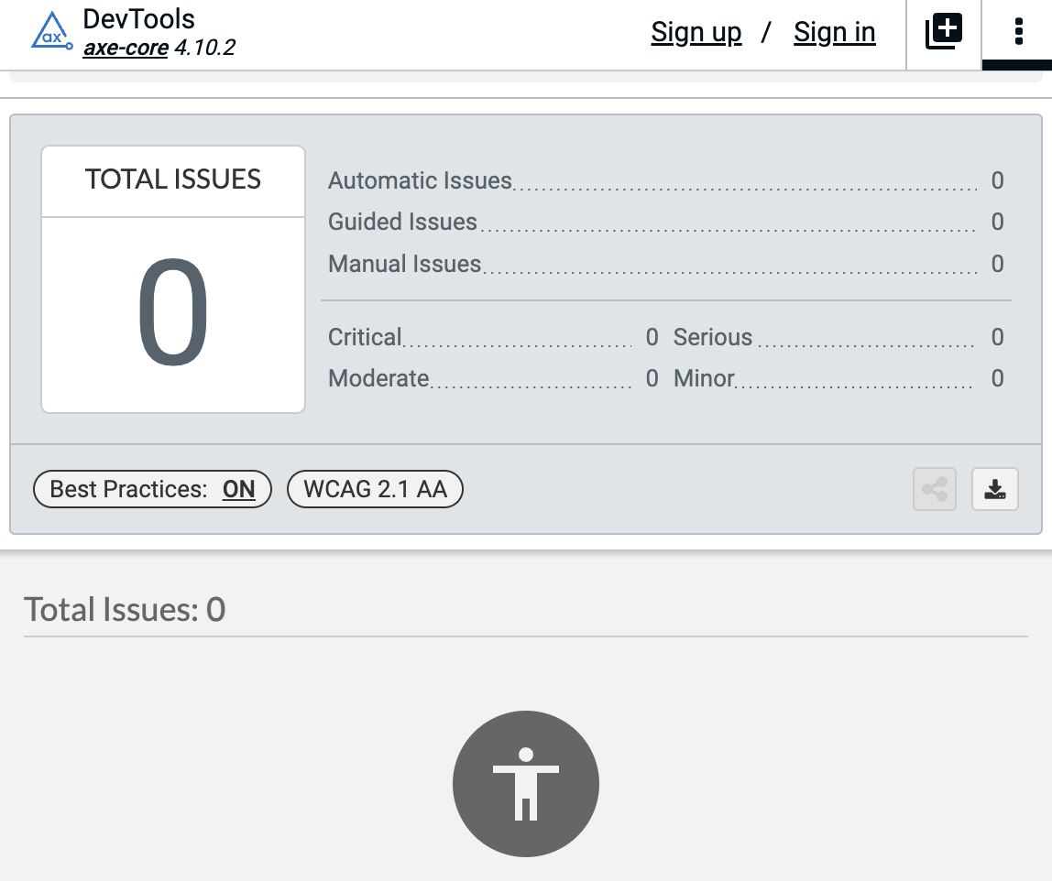

1. [Step 1/3: Your personal information - applicant name](https://staging.va.gov/education/apply-for-education-benefits/10282/applicant/information)

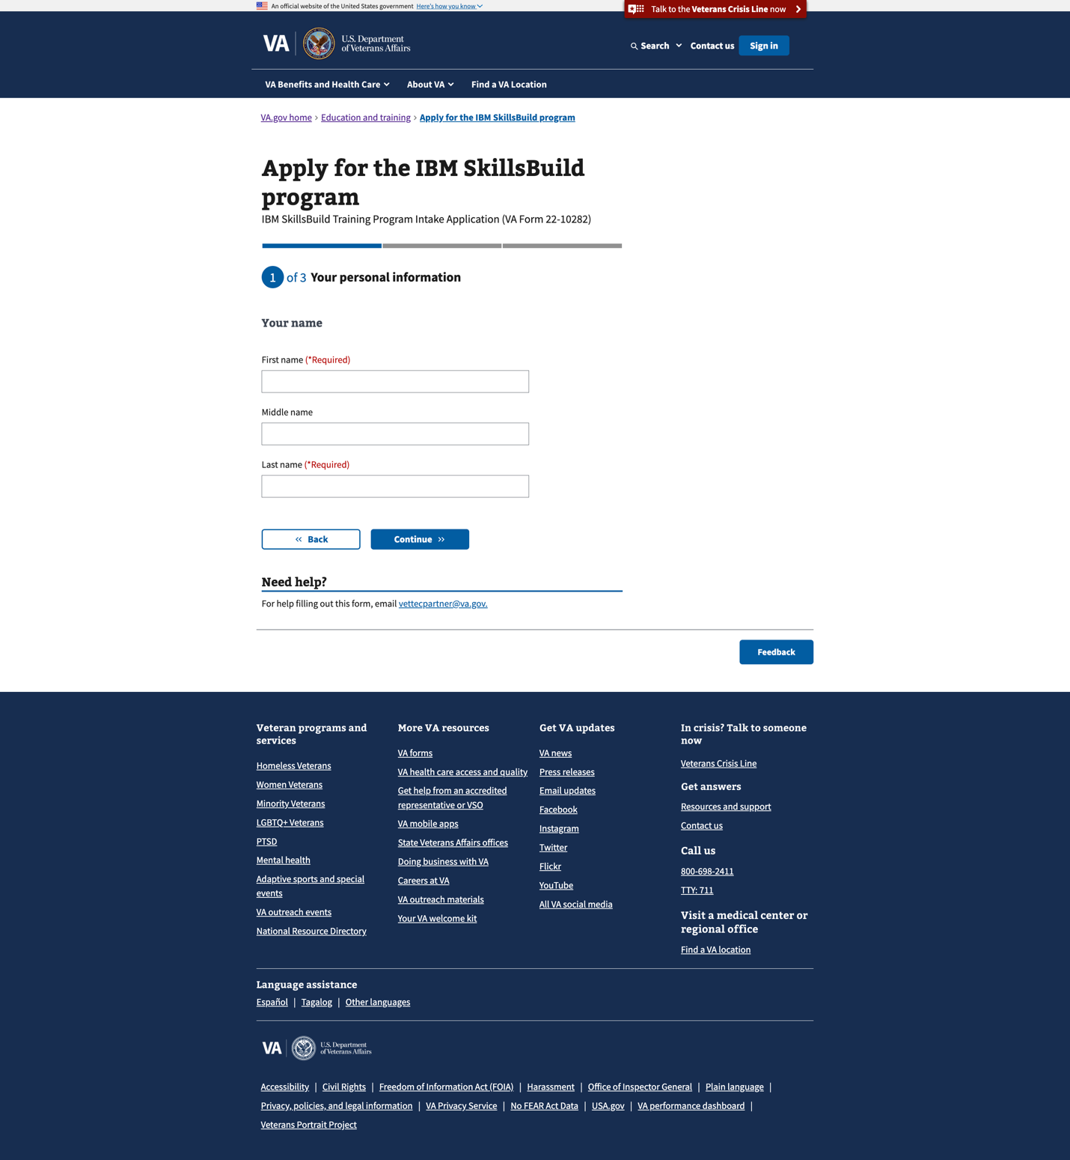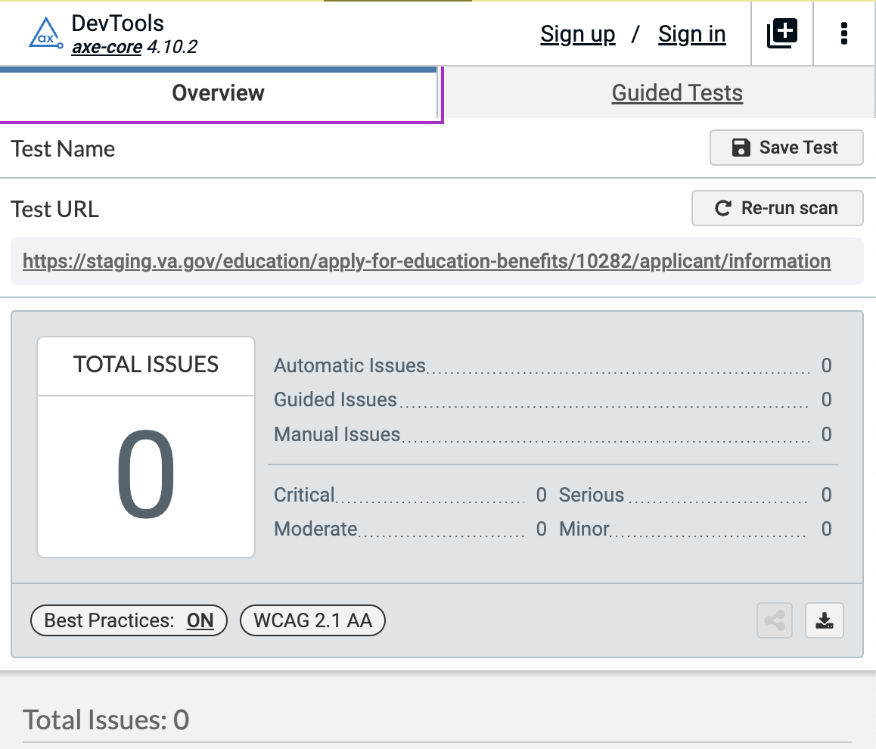

1. [Step 1/3: Your personal information - relationship to Veteran](https://staging.va.gov/education/apply-for-education-benefits/10282/applicant-information-1)

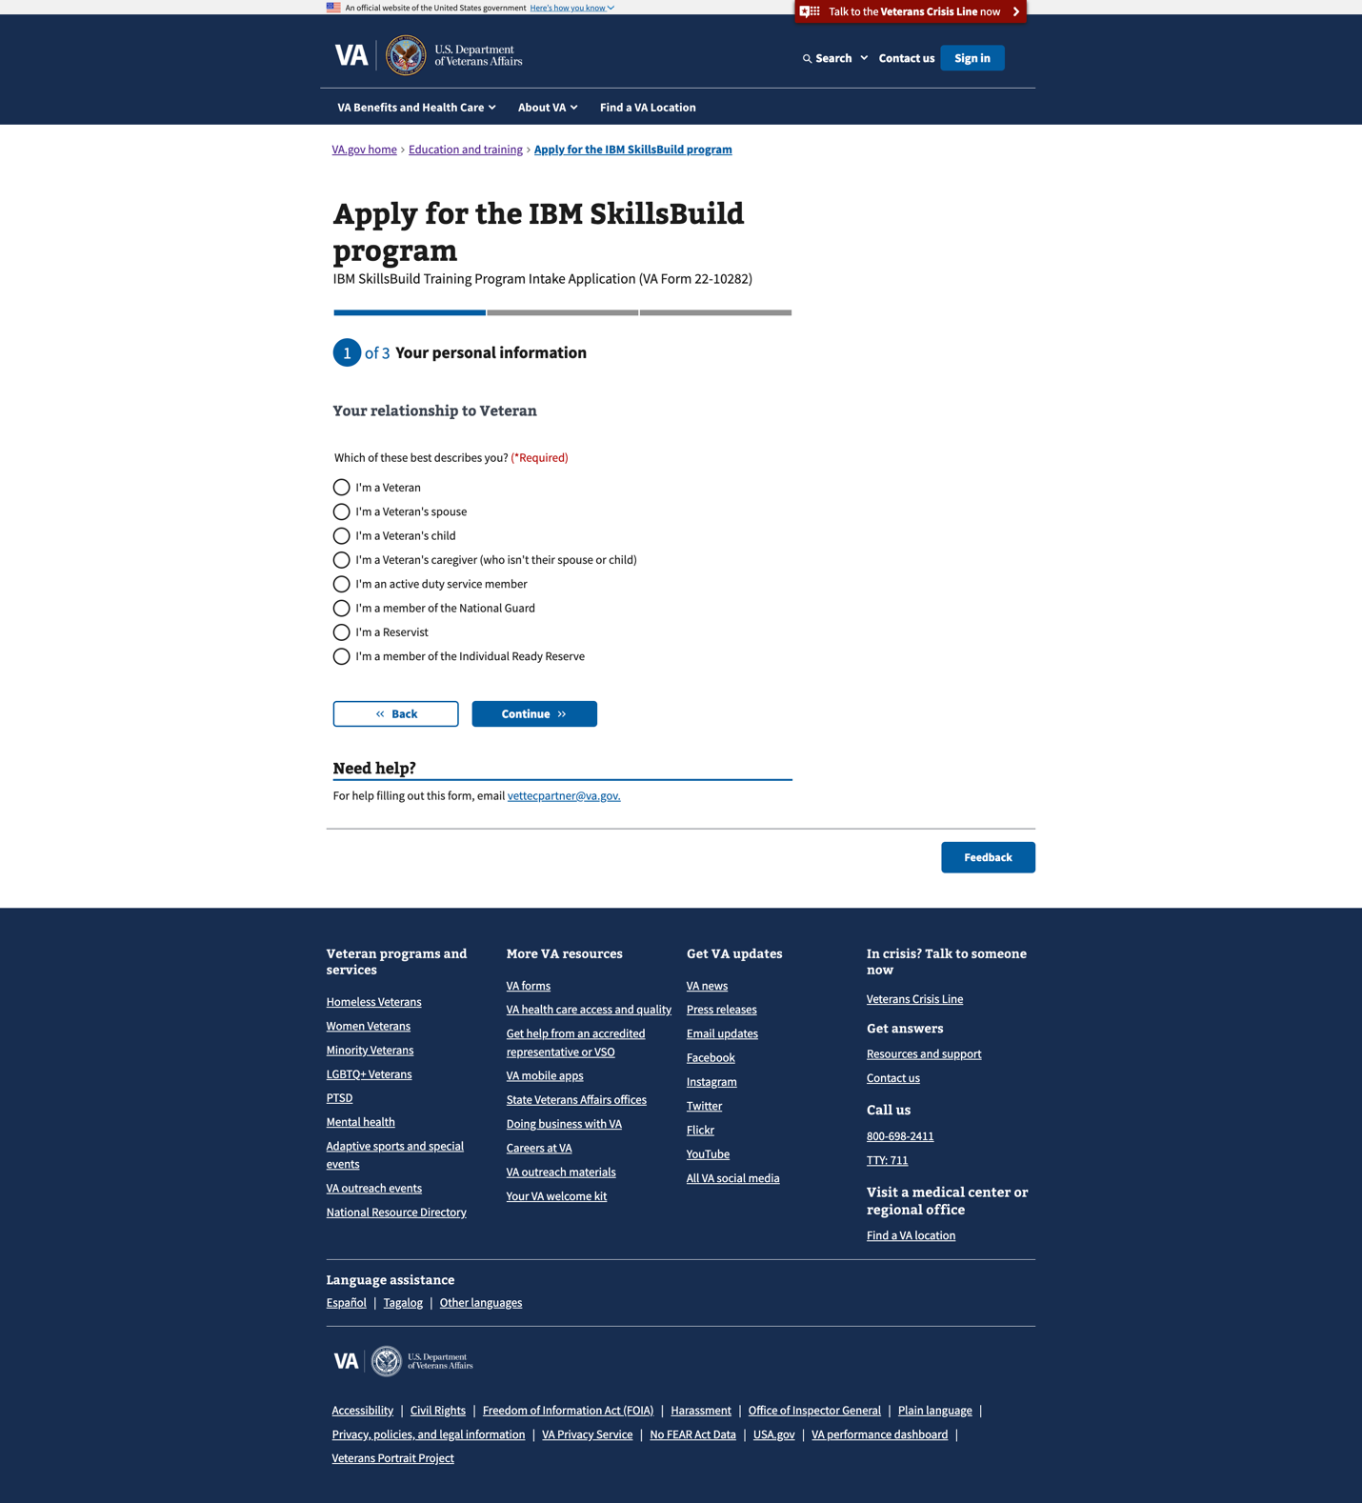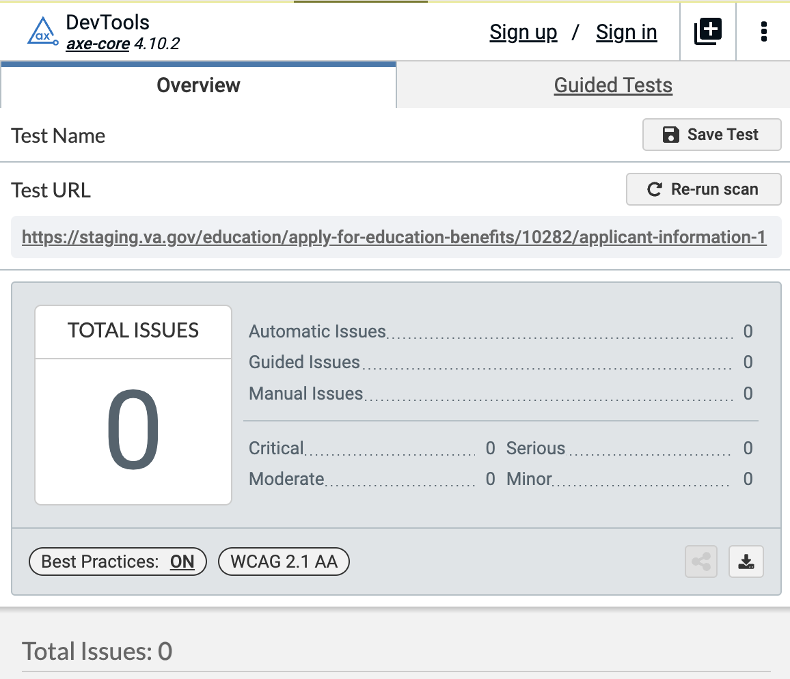

1. [Step 1/3: Your personal information - contact information](https://staging.va.gov/education/apply-for-education-benefits/10282/applicant-information-2)

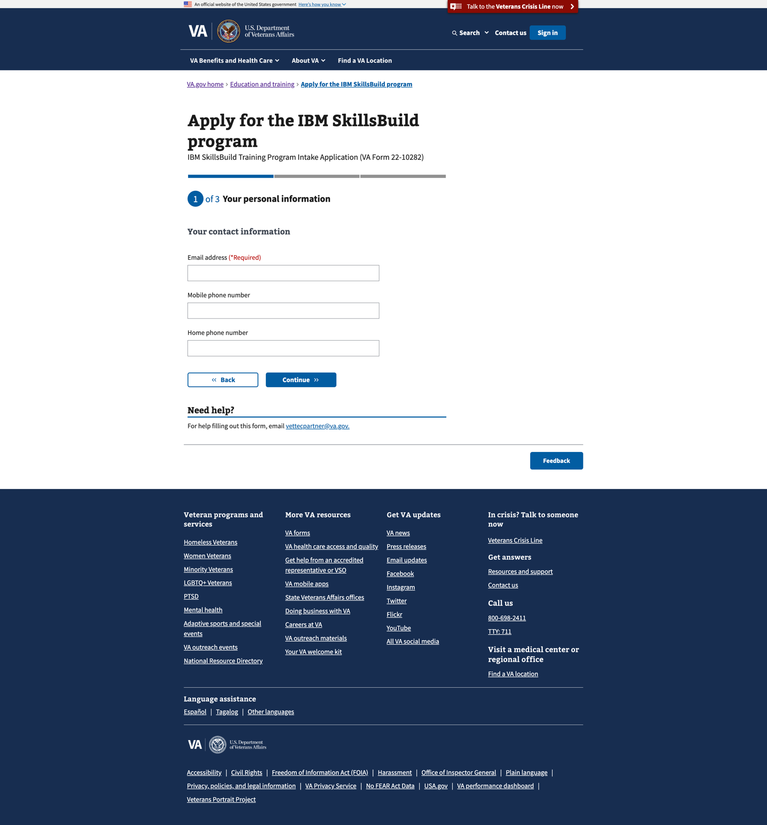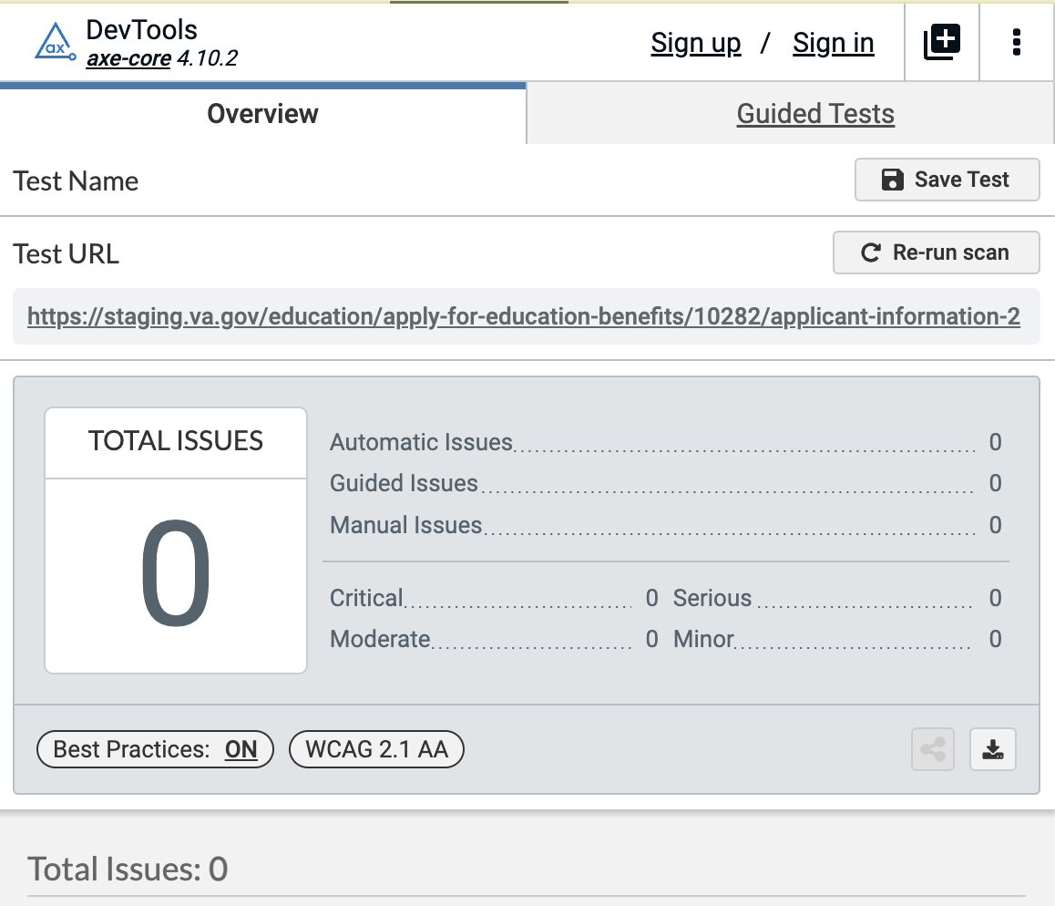

1. [Step 1/3: Your personal information - country of residence](https://staging.va.gov/education/apply-for-education-benefits/10282/applicant-information-3)

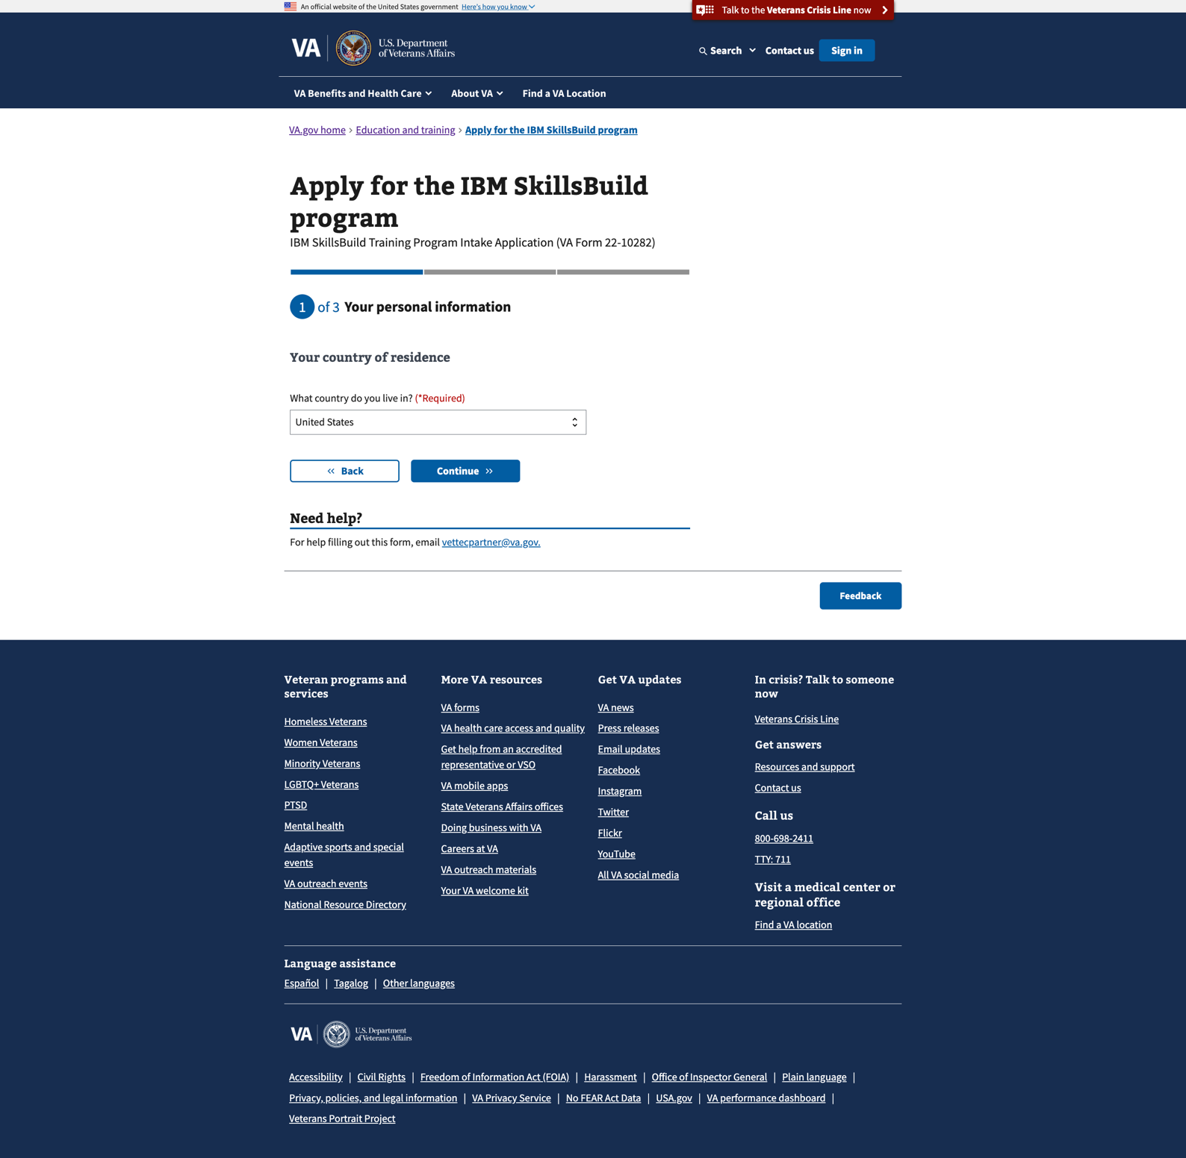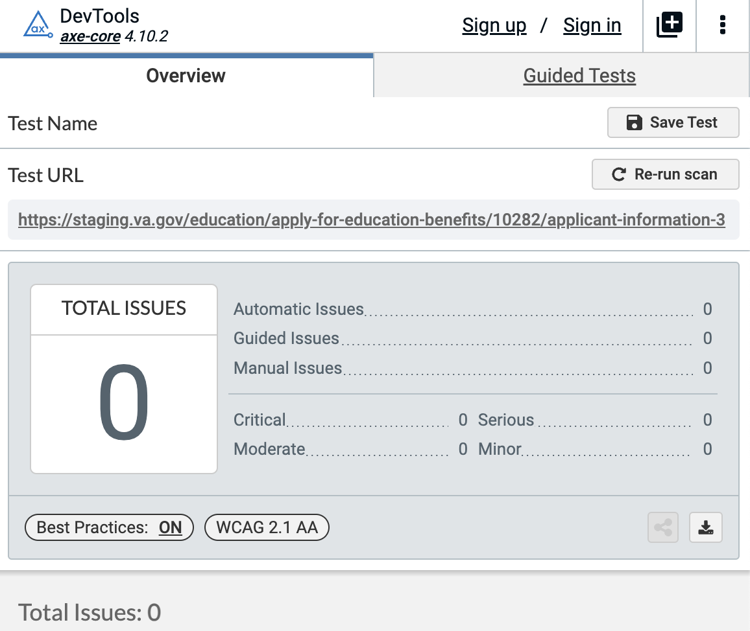

1. 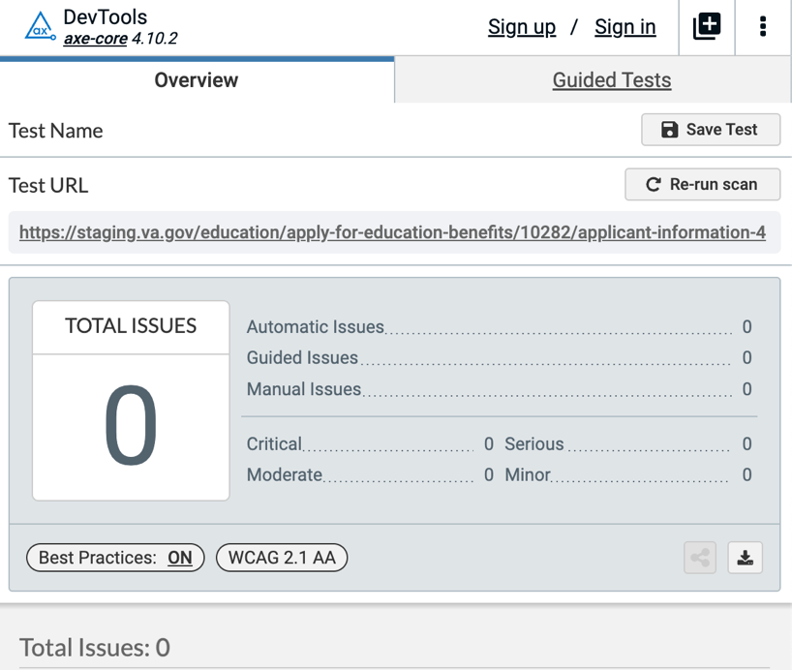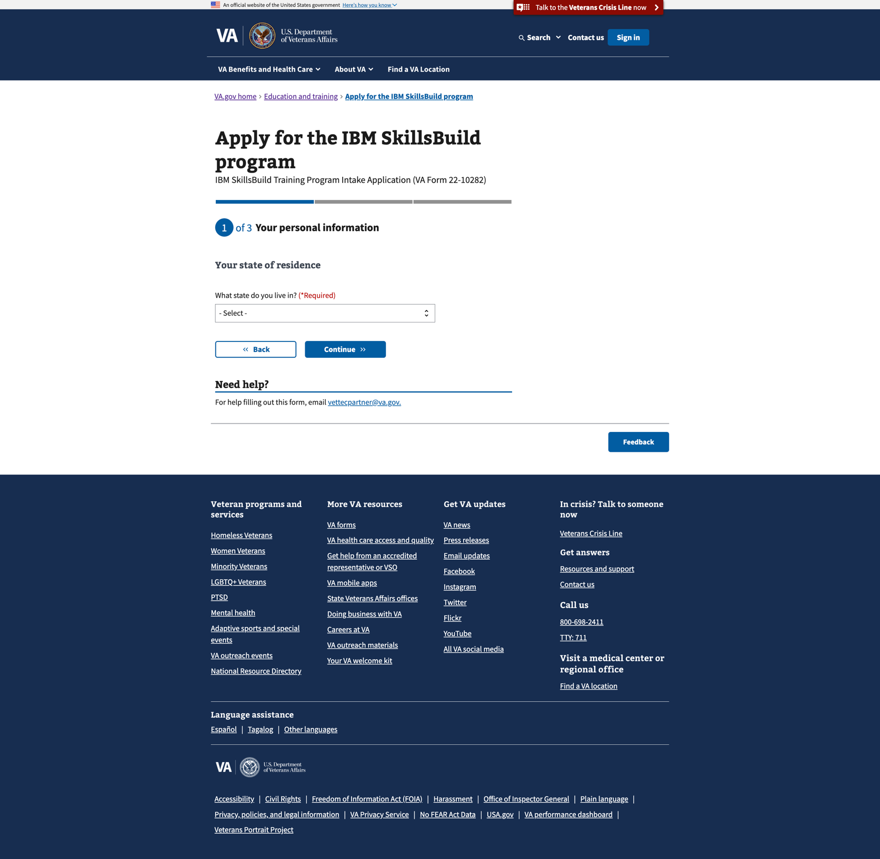[Step 1/3: Your personal information - state of residence](https://staging.va.gov/education/apply-for-education-benefits/10282/applicant-information-4)
2. [Step 1/3: Your personal information - optional demographic information](https://staging.va.gov/education/apply-for-education-benefits/10282/applicant-information-5)

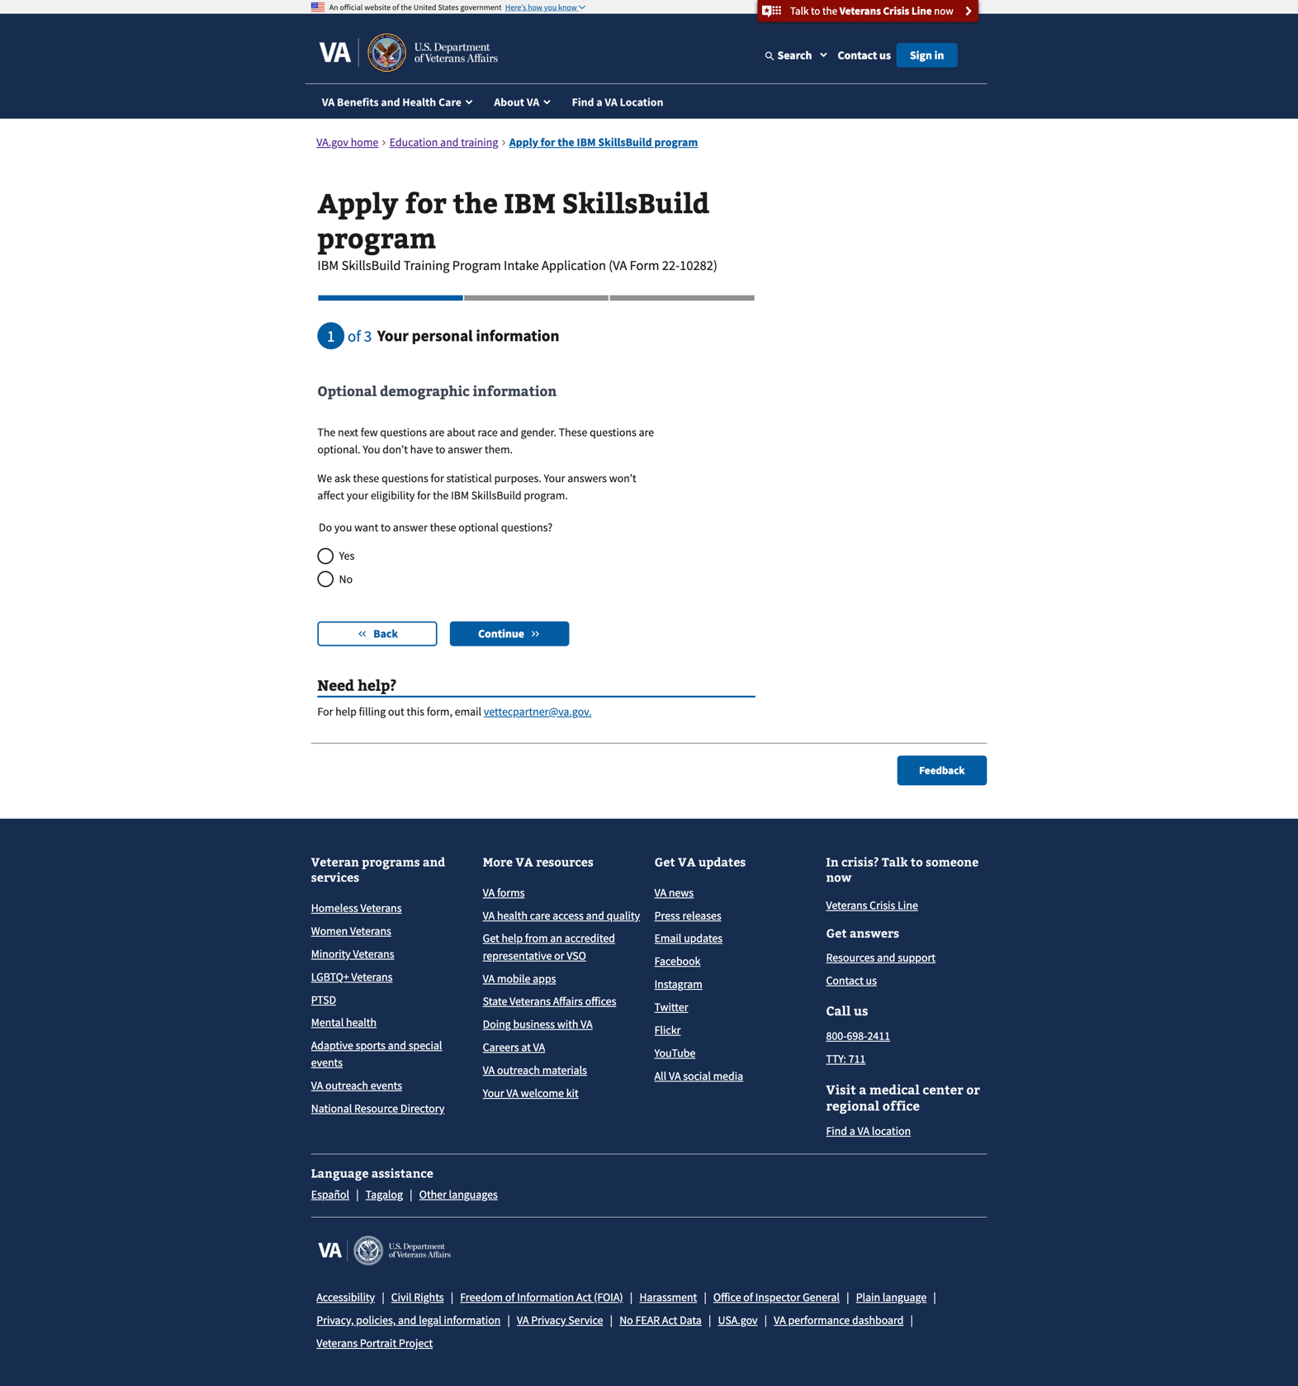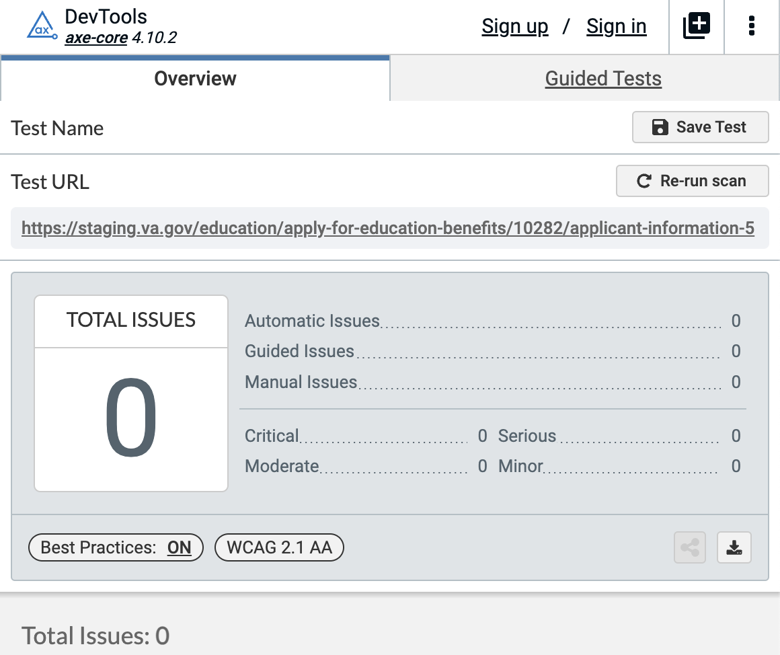

1. [Step 1/3: Your personal information - demographics (ethnicity and race)](https://staging.va.gov/education/apply-for-education-benefits/10282/applicant-information-6)

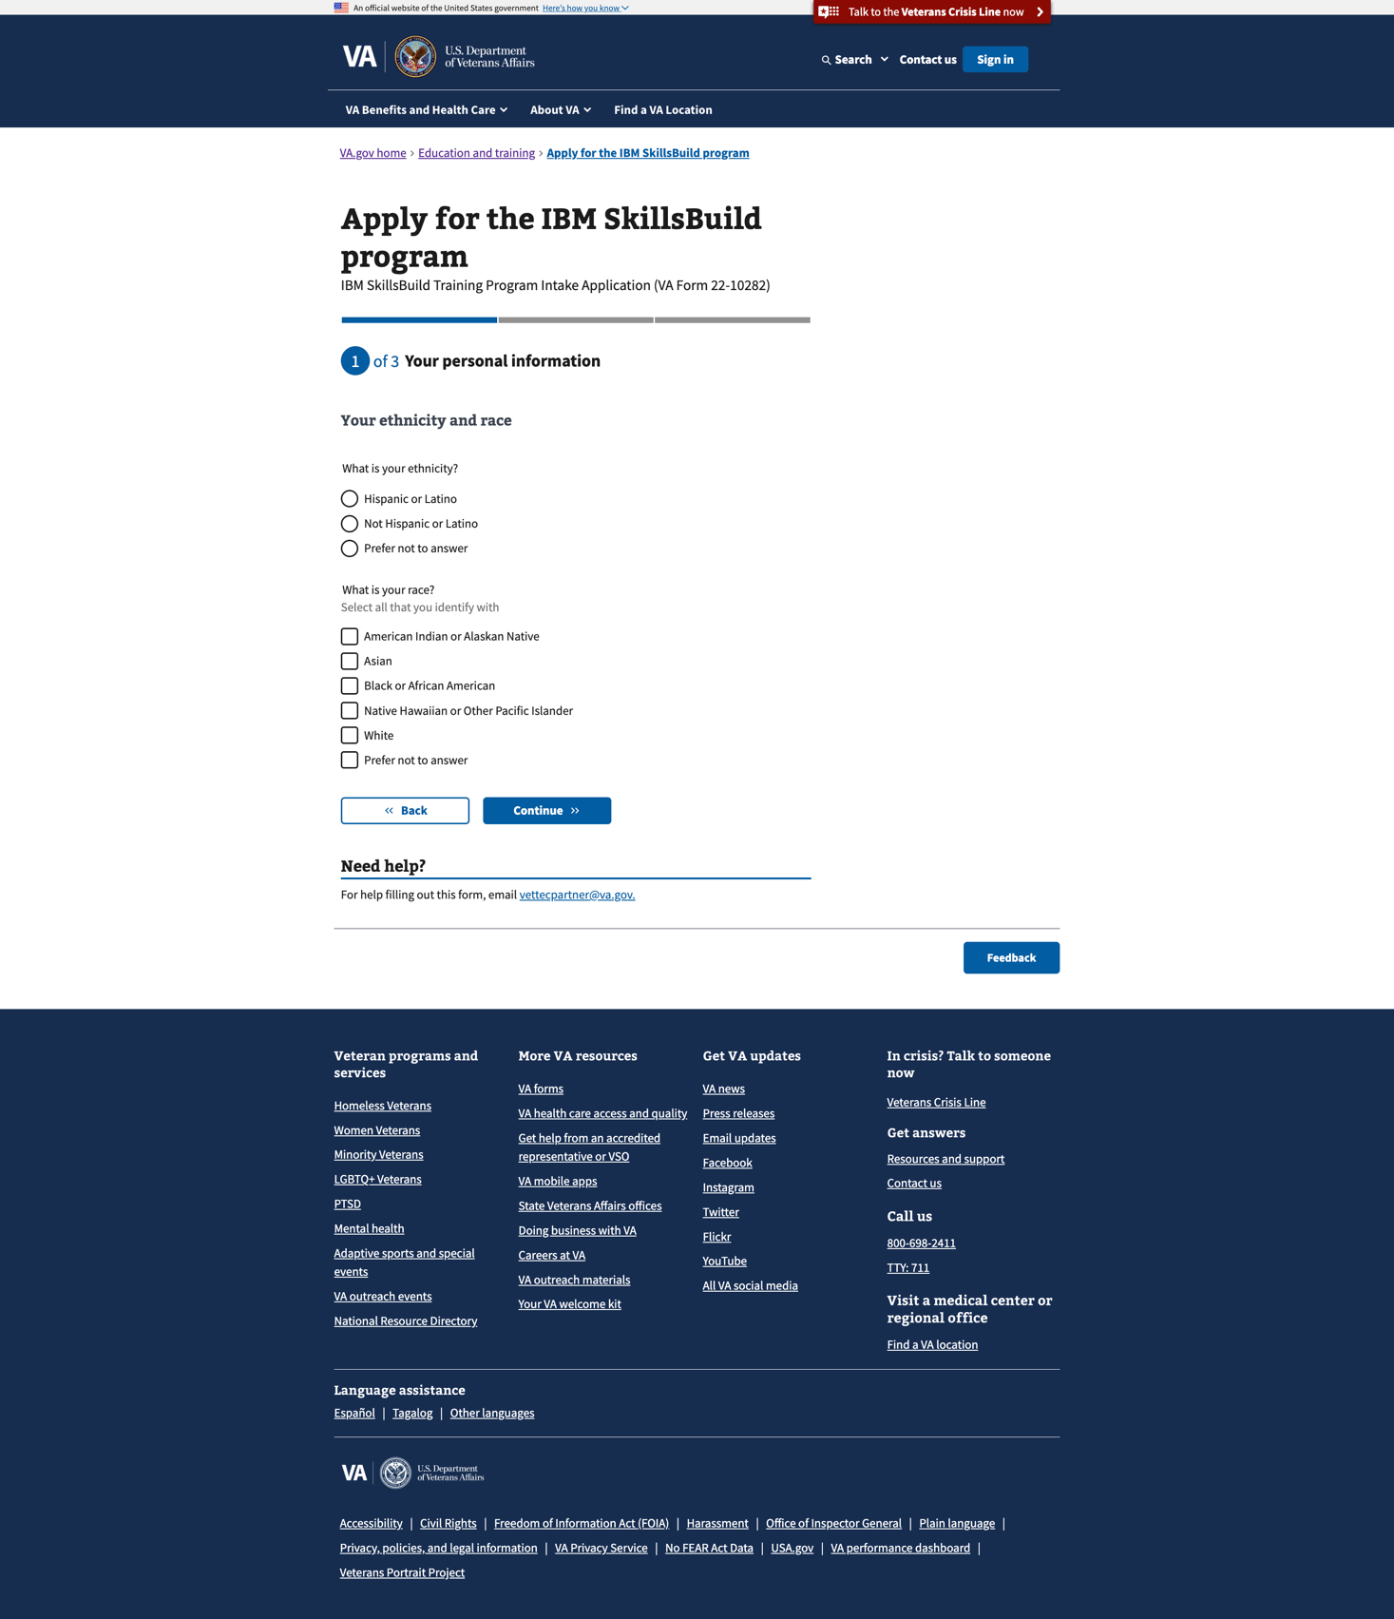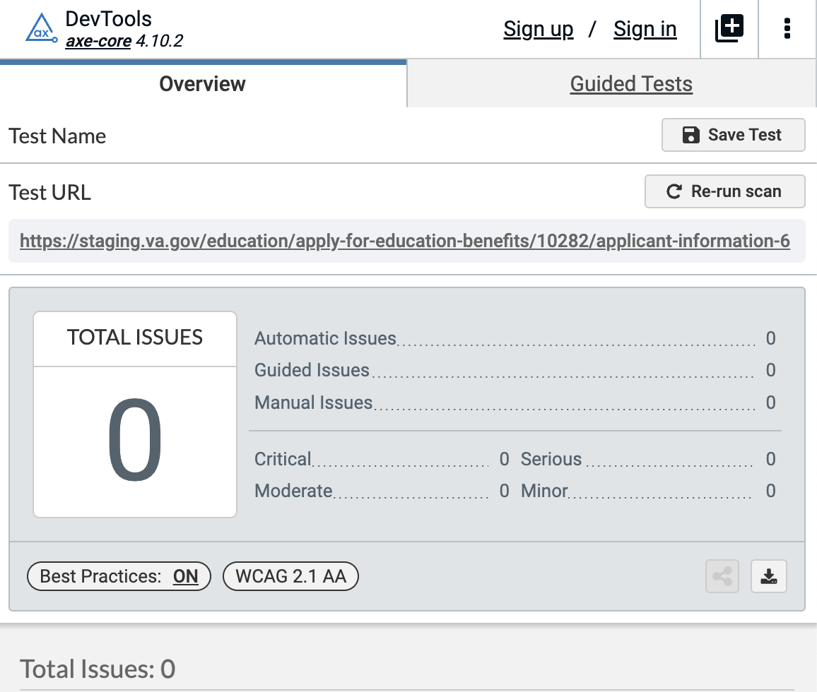

1. [Step 1/3: Your personal information – demographics (gender)](https://staging.va.gov/education/apply-for-education-benefits/10282/applicant-information-7)

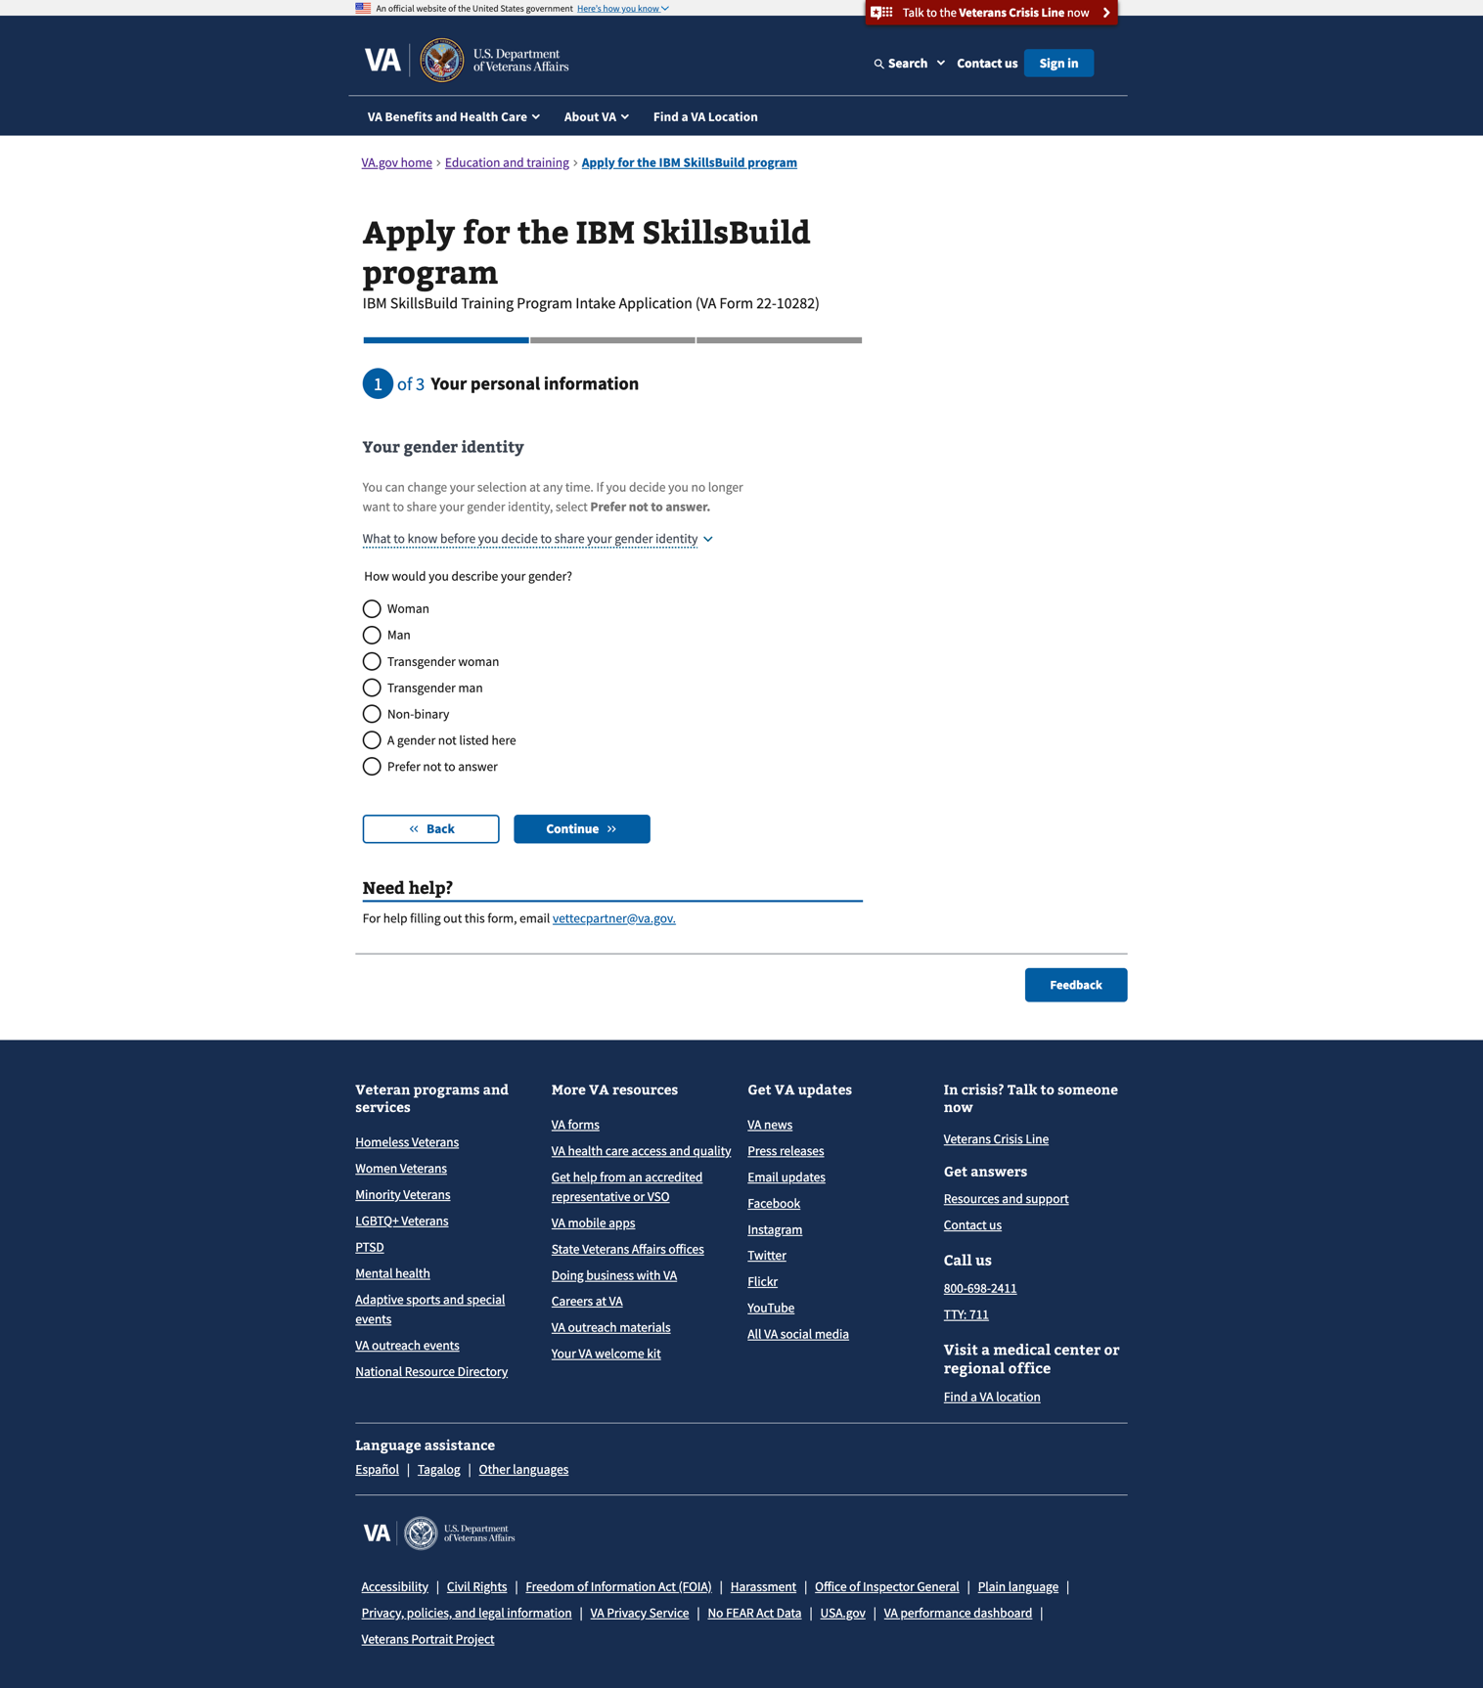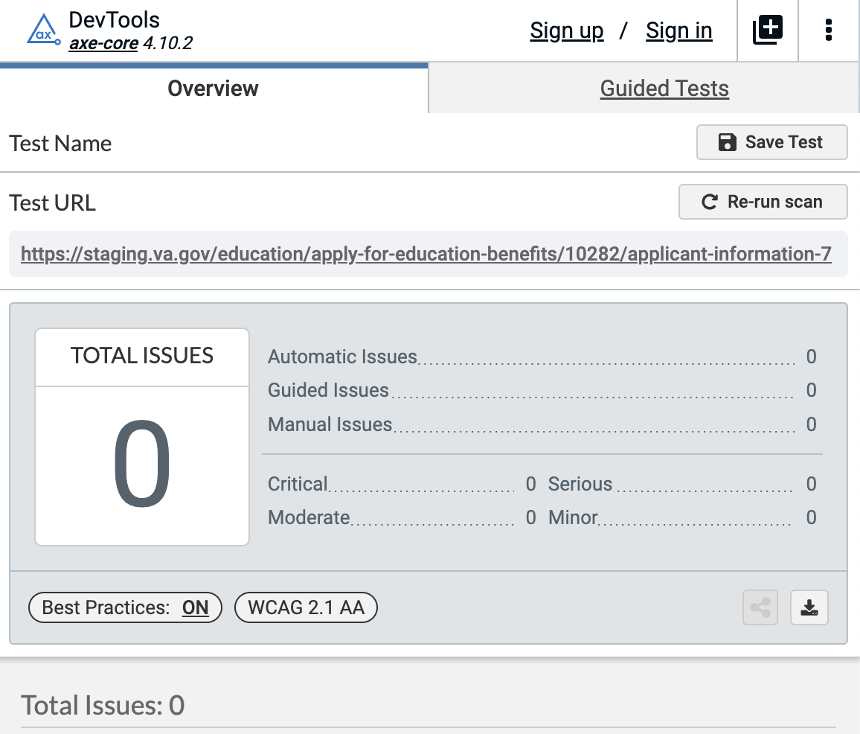

1. [Step 2/3: Education and employment history – education level](https://staging.va.gov/education/apply-for-education-benefits/10282/education-employment-history-1)

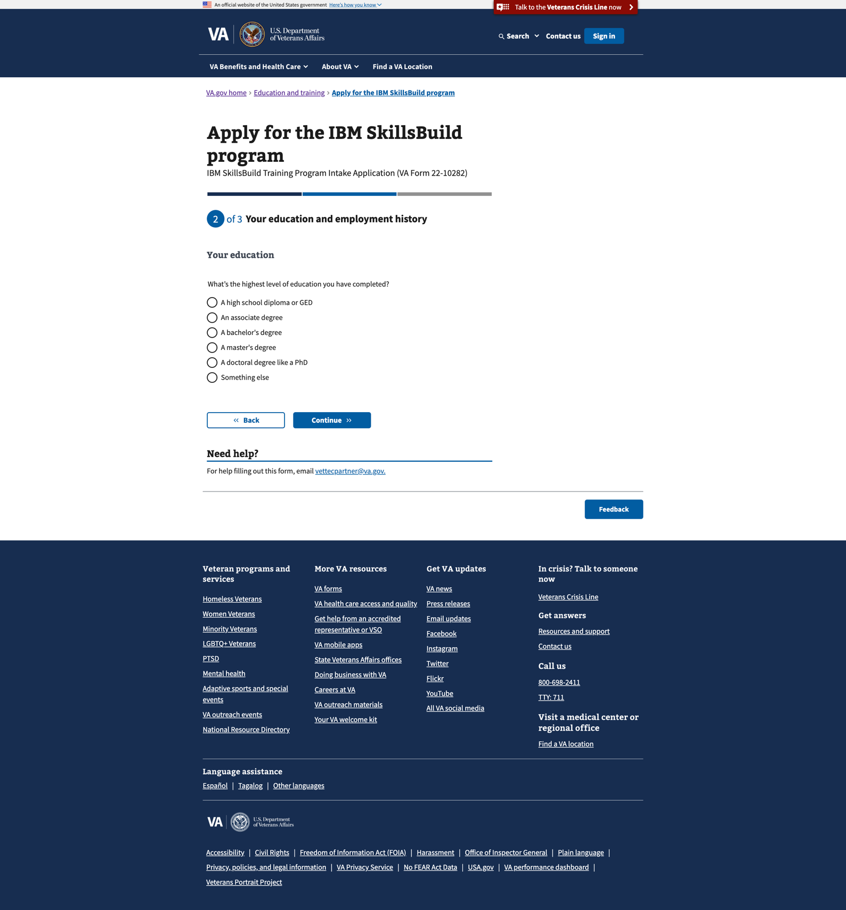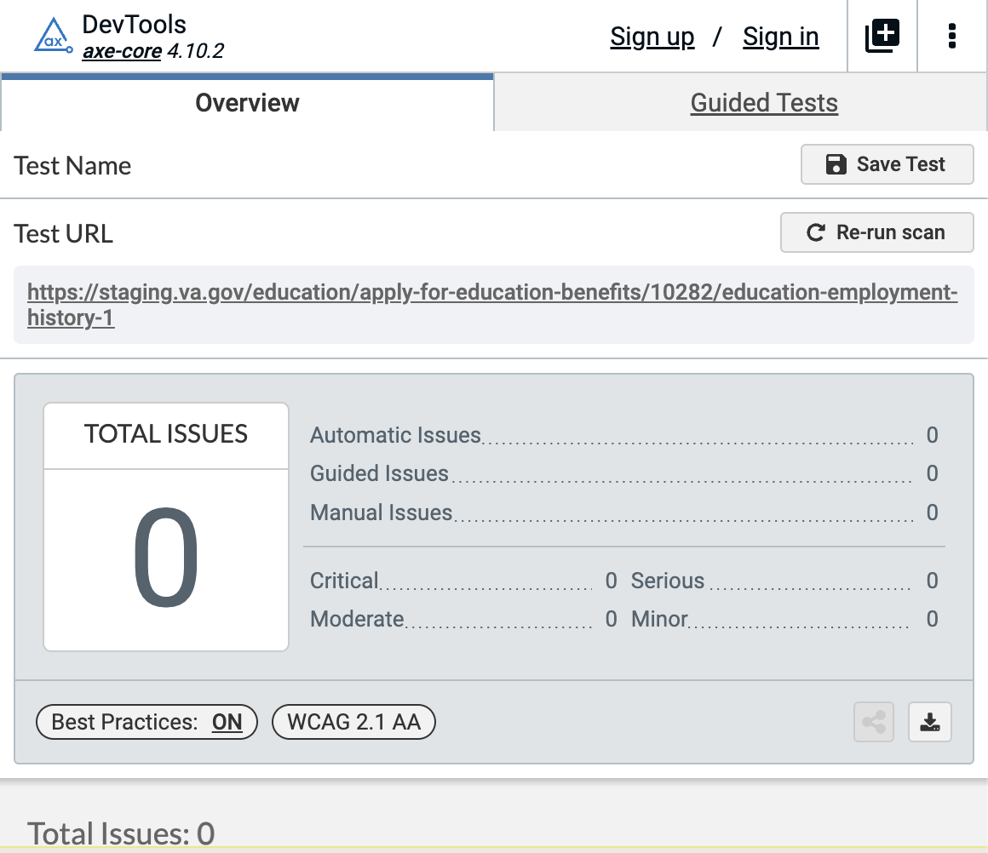

1. [Step 2/3: Education and employment history – employment status](https://staging.va.gov/education/apply-for-education-benefits/10282/education-employment-history-2)

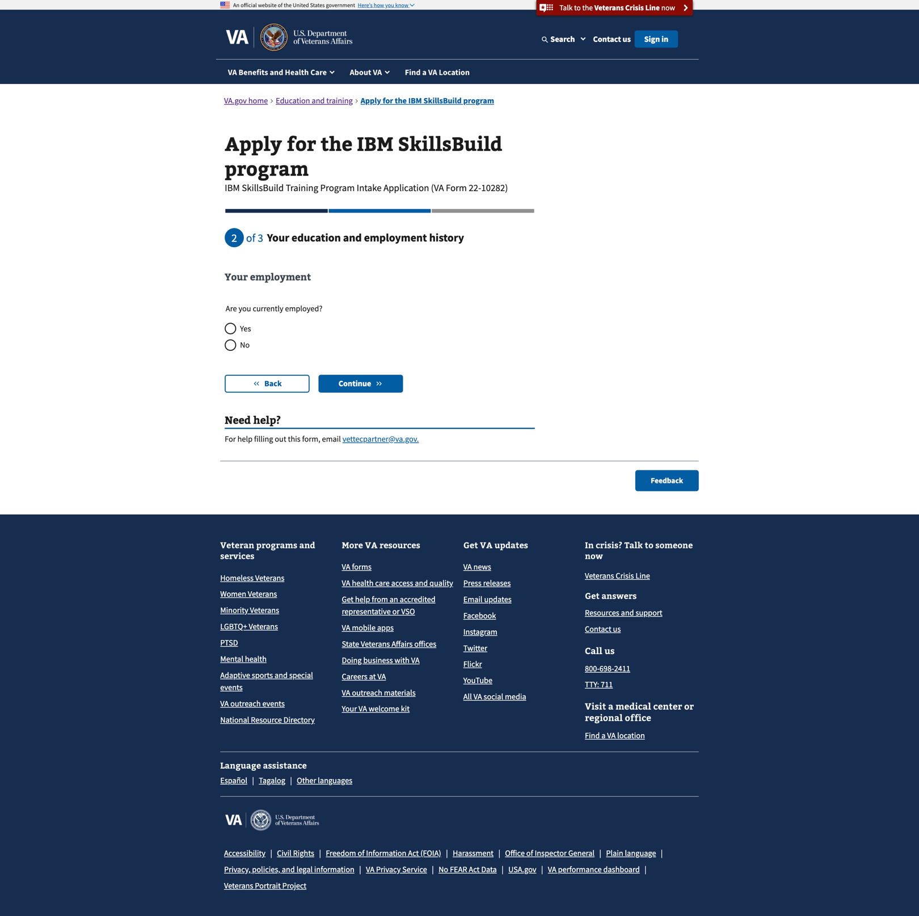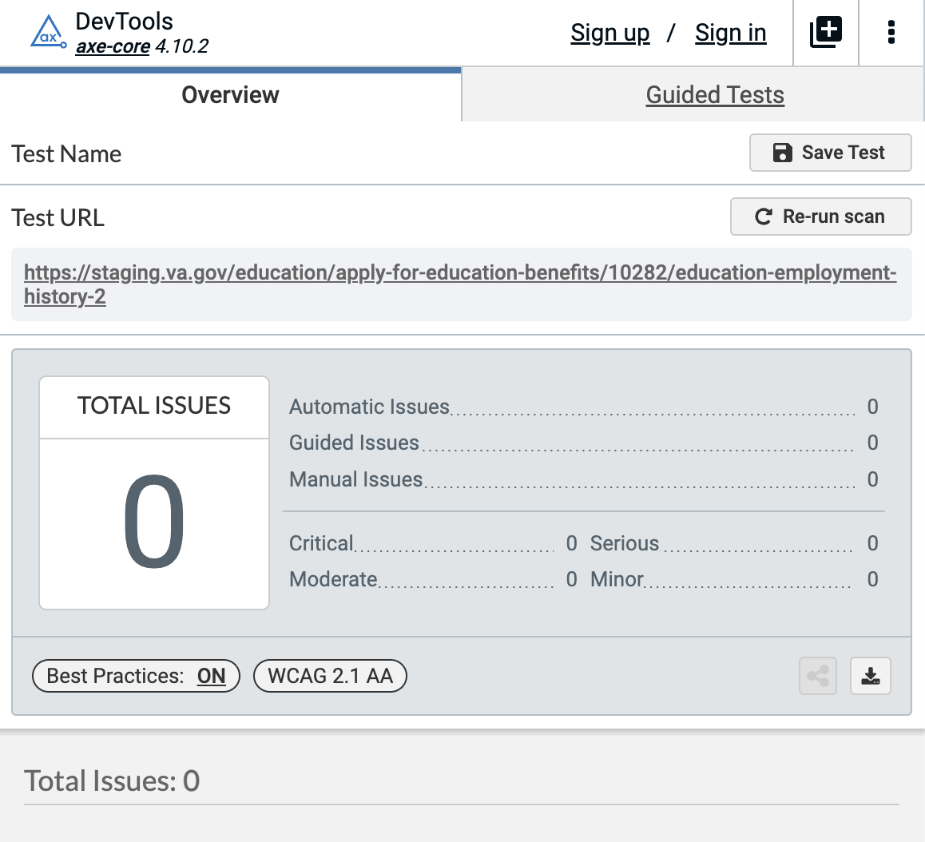

1. [Step 2/3: Education and employment history – annual salary](https://staging.va.gov/education/apply-for-education-benefits/10282/education-employment-history-3)

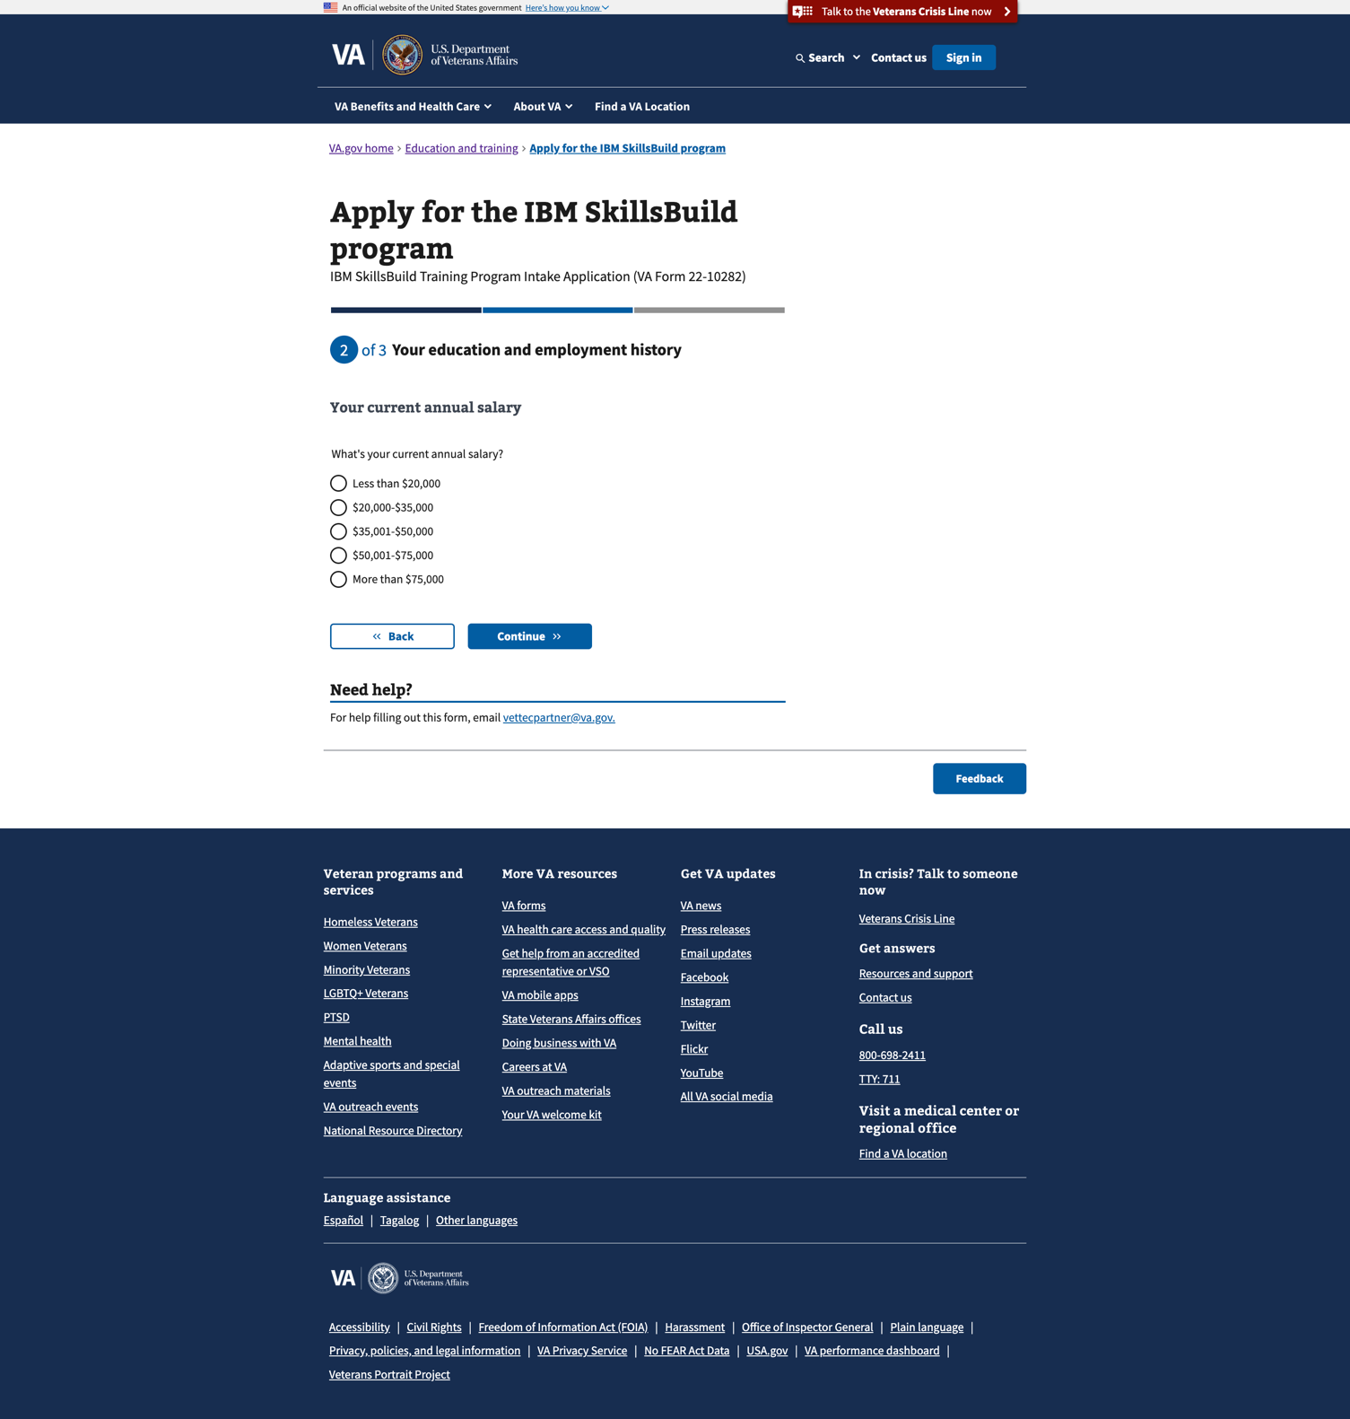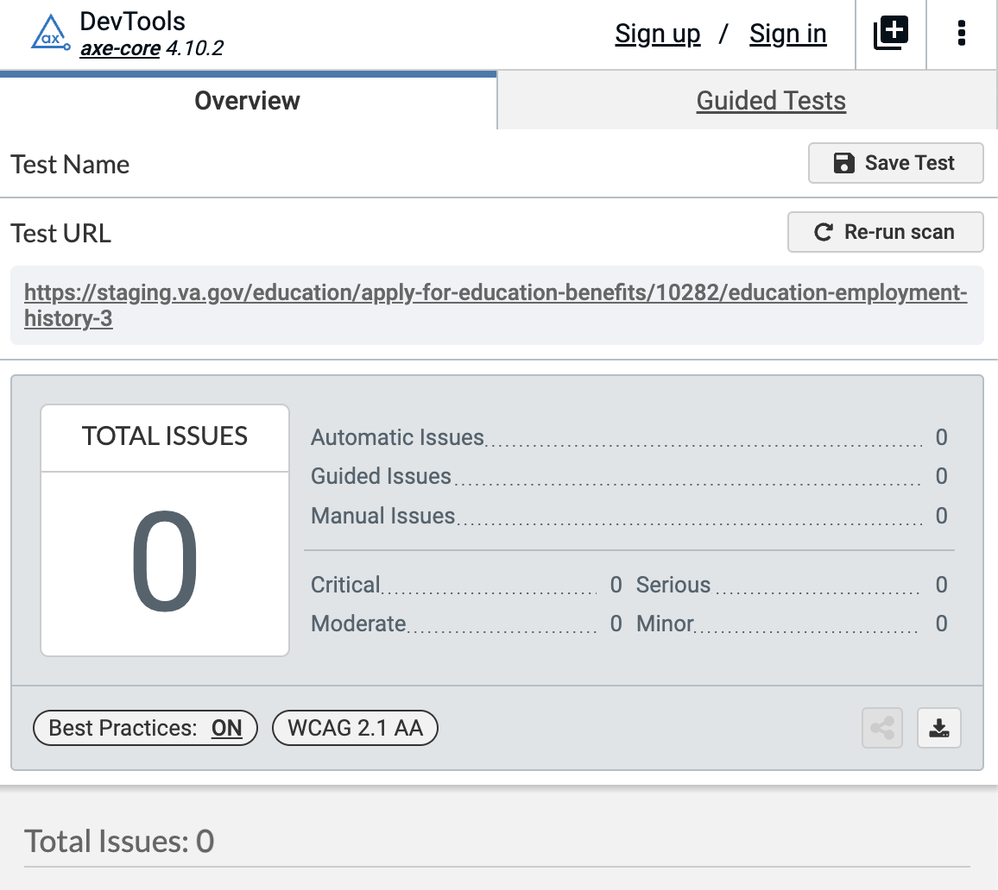

1. [Step 2/3: Education and employment history – tech. industry involvement](https://staging.va.gov/education/apply-for-education-benefits/10282/education-employment-history-4)

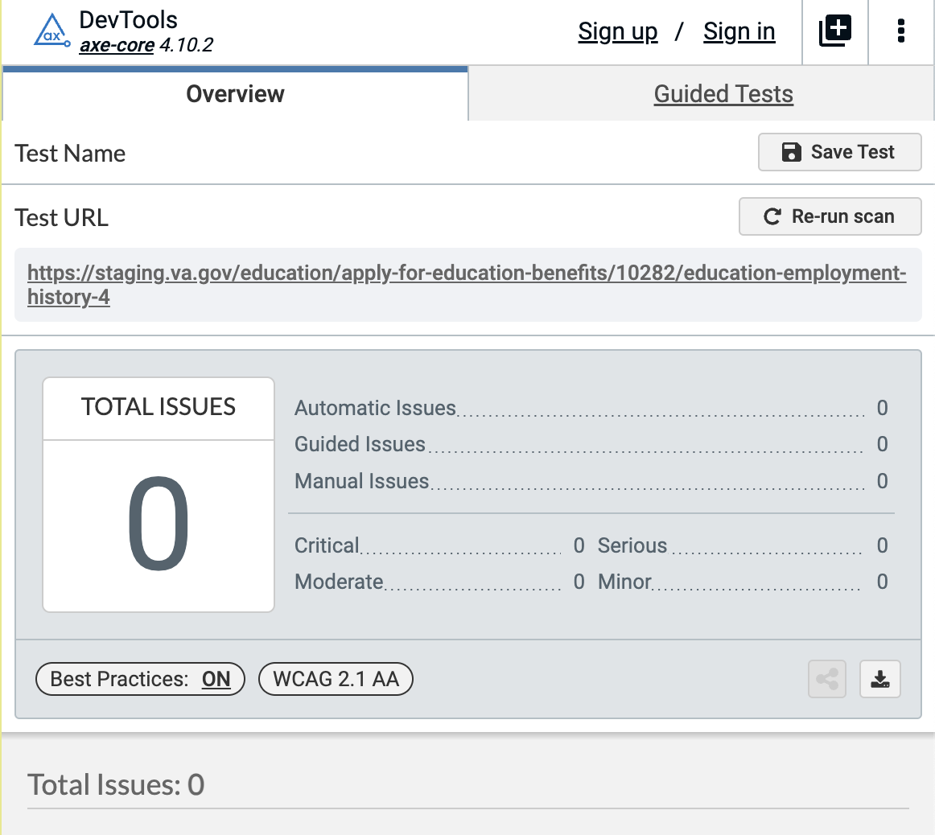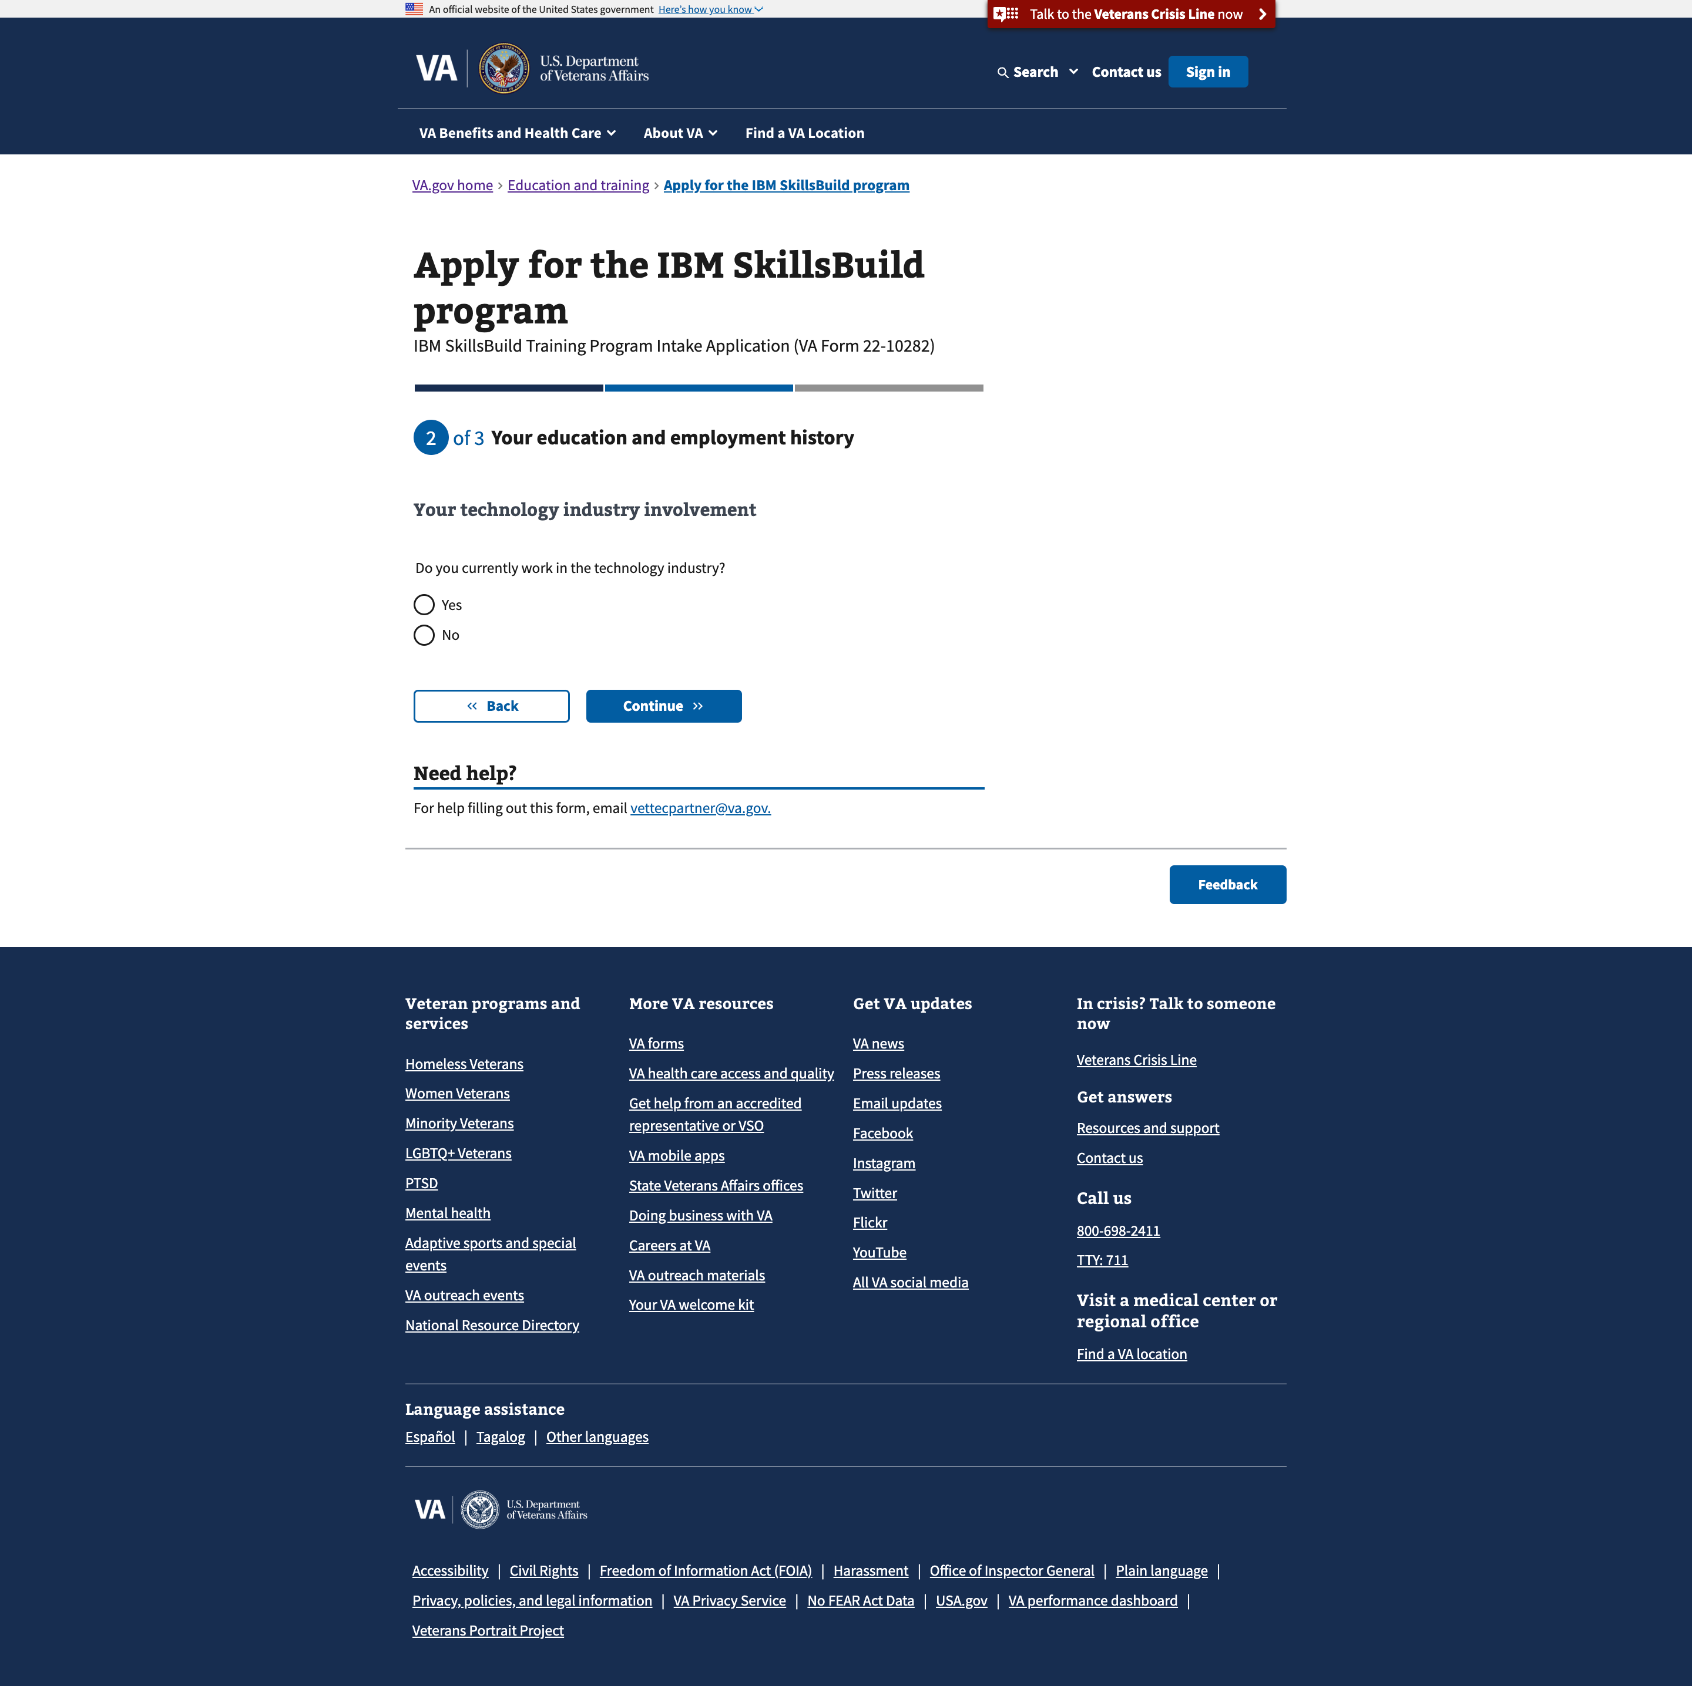

1. [Step 2/3: Education and employment history – area of focus in tech. industry](https://staging.va.gov/education/apply-for-education-benefits/10282/education-employment-history-5)

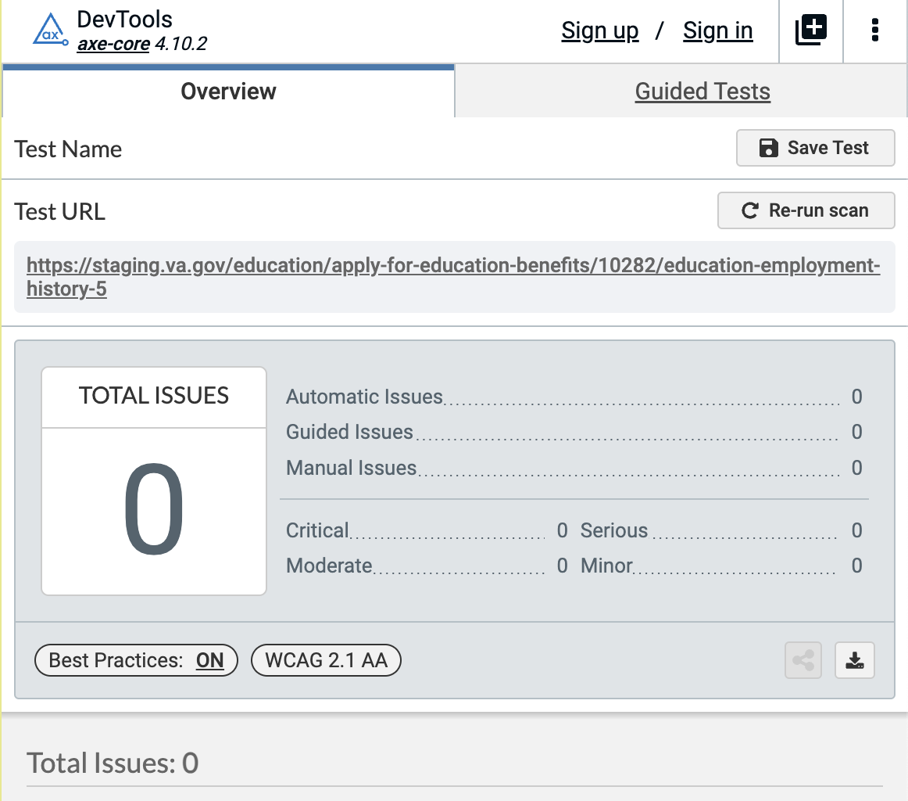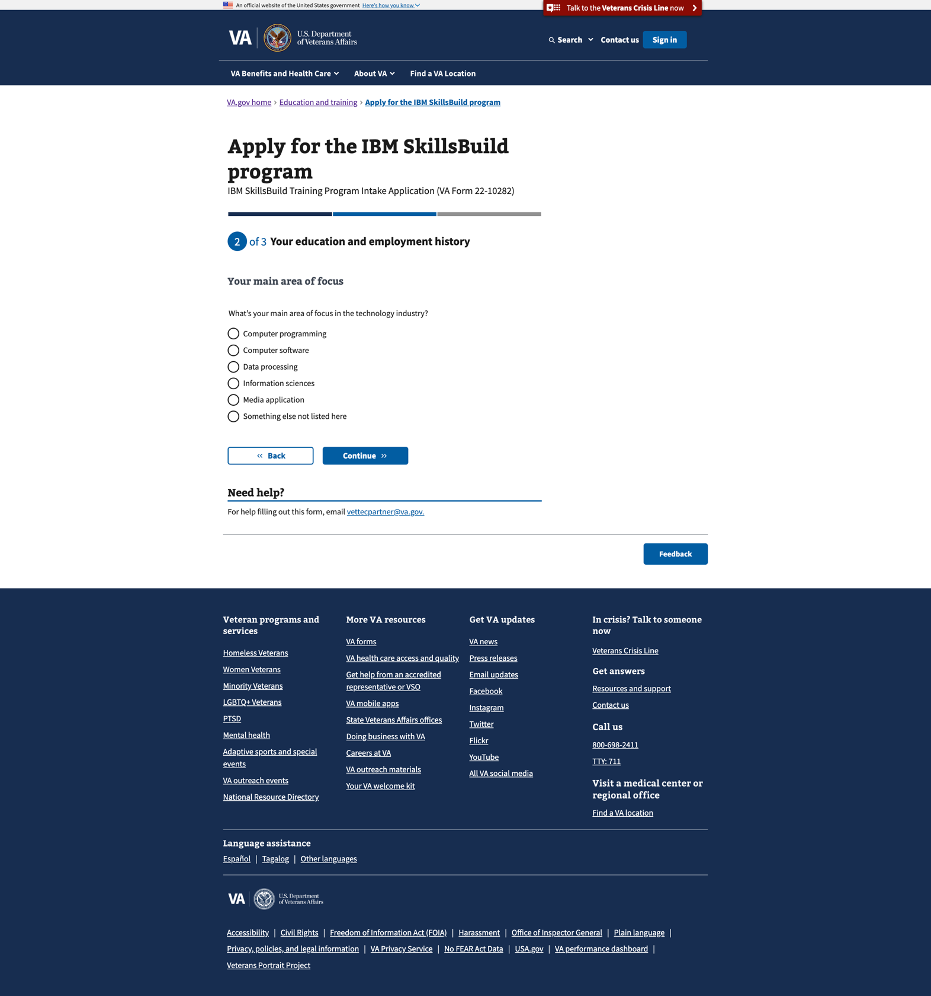

1. [Step 3/3: Review and submit application](https://staging.va.gov/education/apply-for-education-benefits/10282/review-and-submit)

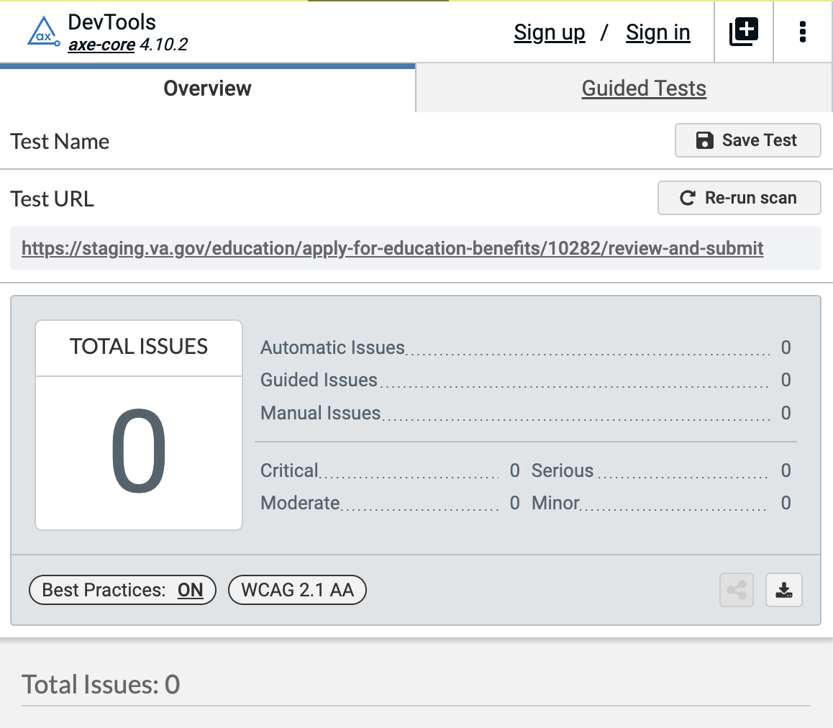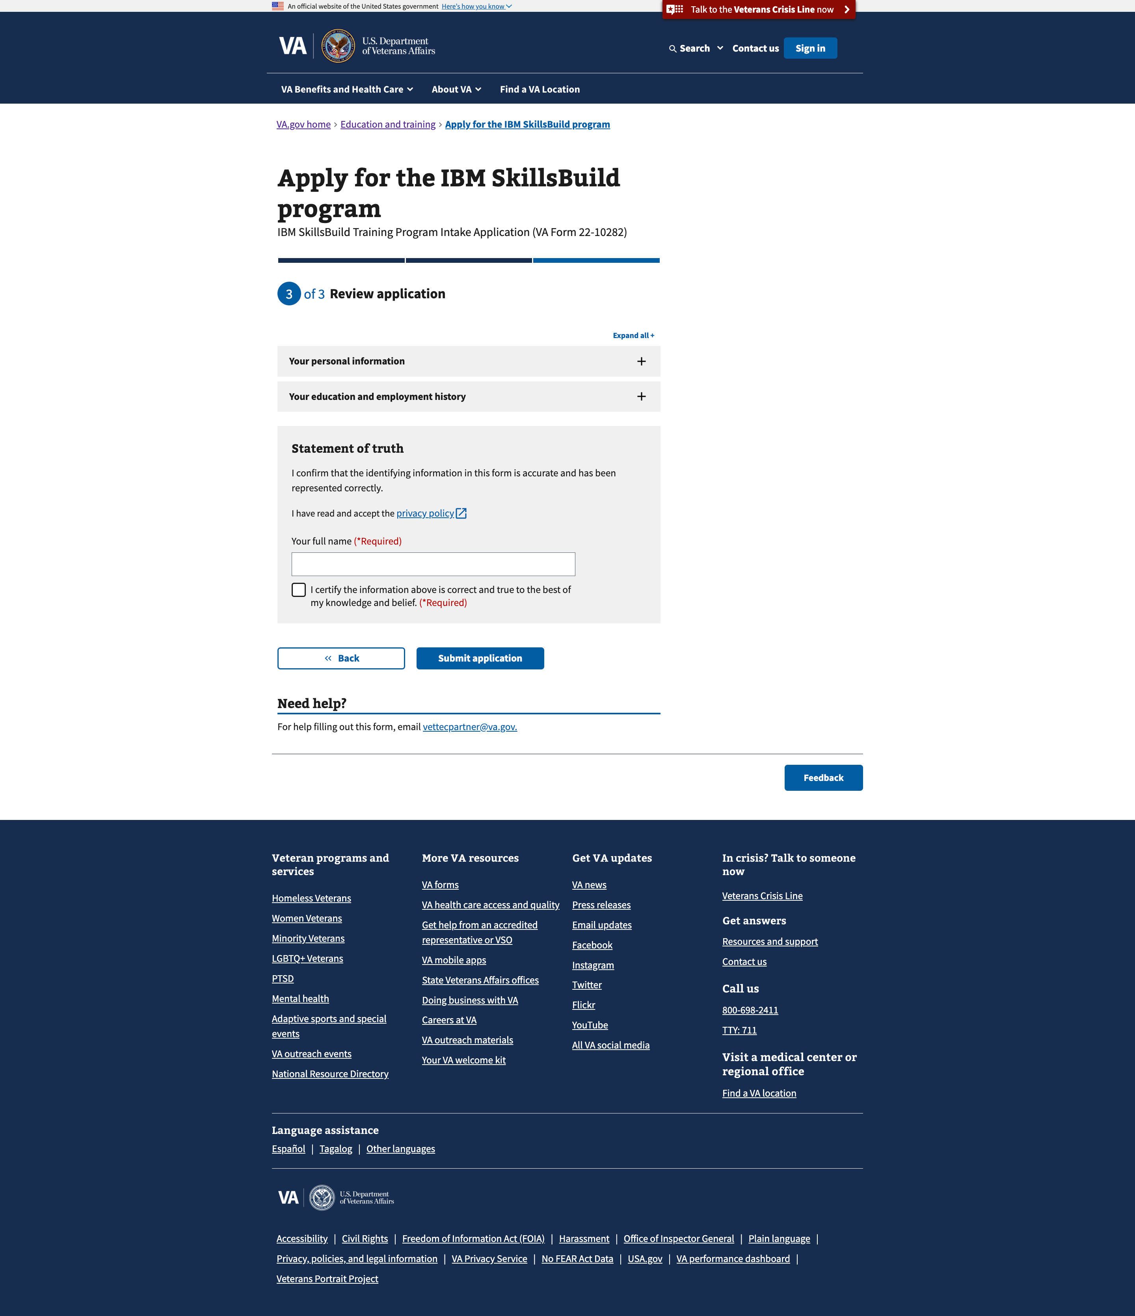

1. [Confirmation page](https://staging.va.gov/education/apply-for-education-benefits/10282/confirmation)

